**JAVA DA 2**

1.

package sample;  
import javafx.application.Application;  
import javafx.event.ActionEvent;  
import javafx.event.EventHandler;  
import javafx.geometry.HPos;  
import javafx.geometry.Insets;  
import javafx.scene.Scene;  
import javafx.scene.control.Button;  
import javafx.scene.layout.GridPane;  
import javafx.stage.Stage;  
import javafx.scene.control.TextField;  
import javafx.scene.control.Label;  
import java.io.PrintWriter;  
  
public class Main extends Application {  
  
 @Override  
 public void start(Stage primaryStage) throws Exception{  
 GridPane root= new GridPane();  
 Label fname= new Label("FirstName: "); //First Name  
 root.add(fname, 0,1);  
 TextField fname1= new TextField();  
 fname1.setMinWidth(200);  
 root.add(fname1,1,1);  
   
 Label lname= new Label("LastName: "); //Last Name  
 root.add(lname,0,2);  
 TextField lname1= new TextField();  
 lname1.setMinWidth(200);  
 root.add(lname1,1,2);  
   
 Label addr= new Label("Address: "); //Address  
 root.add(addr,0,3);  
 TextField addr1= new TextField();  
 addr1.setPromptText("Street no");  
 root.add(addr1,1,3);  
 TextField addr2= new TextField();  
 addr2.setPromptText("Street Name");  
 root.add(addr2,2,3);  
 TextField addr3= new TextField();  
 addr3.setPromptText("City");  
 root.add(addr3,3,3);  
 TextField addr4= new TextField();  
 addr4.setPromptText("State");  
 root.add(addr4,4,3);  
 TextField addr5= new TextField();  
 addr5.setPromptText("Zipcode");  
 root.add(addr5,5,3);  
   
 Label email= new Label("Email: "); //Email  
 root.add(email,0,4);  
 TextField email1= new TextField();  
 root.add(email1,1,4);  
   
 Label Pno= new Label("Ph No: "); //Phone Number  
 root.add(Pno,2,4);  
 TextField Pno1= new TextField();  
 root.add(Pno1,3,4);  
   
 Label off= new Label("Office: "); //Office  
 root.add(off,0,5);  
 TextField off1= new TextField();  
 root.add(off1,1,5);  
   
 Label title= new Label("Title: "); //Title  
 root.add(title,0,6);  
 TextField title1= new TextField();  
 root.add(title1,1,6);  
   
 Label rank= new Label("Rank: "); //Rank  
 root.add(rank,0,7);  
 TextField rank1= new TextField();  
 root.add(rank1,1,7);  
   
 Label sal= new Label("Salary: "); //Salary  
 root.add(sal,0,8);  
 TextField sal1= new TextField();  
 root.add(sal1,1,8);  
   
 TextField emp= new TextField(); //About  
 emp.setMinSize(300,300);  
 root.add(emp,2,5);  
   
 Button btn= new Button("Add"); //Button  
 btn.setOnAction(new EventHandler<ActionEvent>() {  
 @Override  
 public void handle(ActionEvent actionEvent) {  
 String fileName="out.txt";  
 try{  
 PrintWriter ostream = new PrintWriter(fileName);  
 ostream.print("First Name: ");  
 ostream.println(fname1.getText());  
 ostream.print("Last Name: ");  
 ostream.println(lname1.getText());  
 ostream.print("Address: ");  
 ostream.println(addr1.getText()+","+addr2.getText()+","+addr3.getText()+","+addr4.getText()+","+addr5.getText());  
 ostream.print("Email: ");  
 ostream.println(email1.getText());  
 ostream.print("Phone Number: ");  
 ostream.println(Pno1.getText());  
 ostream.print("Office: ");  
 ostream.println(off1.getText());  
 ostream.print("Title: ");  
 ostream.println(title1.getText());  
 ostream.print("Rank: ");  
 ostream.println(rank1.getText());  
 ostream.print("Salary: ");  
 ostream.println(sal1.getText());  
 ostream.print("About: ");  
 ostream.println(emp.getText());  
 ostream.close();  
 }  
 catch(Exception e){  
 e.getStackTrace();  
 }  
 }  
 });  
   
 btn.setPrefHeight(40);  
 btn.setDefaultButton(true);  
 btn.setPrefWidth(100);  
 root.setHgap(15);  
 root.setVgap(15);  
 root.setPadding(new Insets(25, 25, 25, 25));  
 root.add(btn, 0, 10, 2, 1);  
 GridPane.*setHalignment*(btn, HPos.*CENTER*);  
 primaryStage.setTitle("Employee Details");  
 primaryStage.setScene(new Scene(root, 800, 800));  
 primaryStage.show();  
 }  
  
  
 public static void main(String[] args) {  
 *launch*(args);  
 }  
}

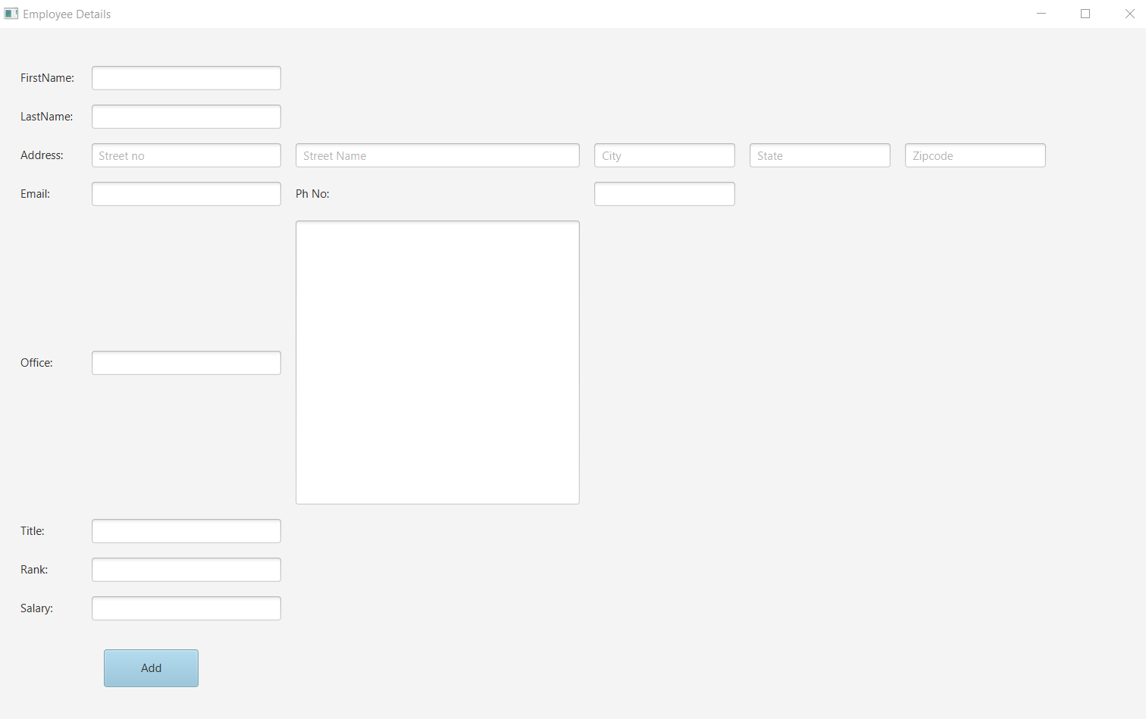

Out.txt 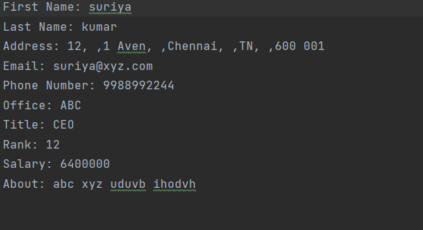

2.

package sample;  
import java.io.*;  
  
import javafx.application.Application;  
import javafx.event.ActionEvent;  
import javafx.event.EventHandler;  
import javafx.geometry.Insets;  
import javafx.geometry.Orientation;  
import javafx.geometry.Pos;  
import javafx.scene.Scene;  
import javafx.scene.control.*;  
import javafx.scene.image.Image;  
import javafx.scene.image.ImageView;  
import javafx.scene.layout.GridPane;  
import javafx.scene.layout.HBox;  
import javafx.scene.layout.StackPane;  
import javafx.scene.text.Font;  
import javafx.scene.text.FontWeight;  
import javafx.scene.text.Text;  
import javafx.stage.Stage;  
public class main2 extends Application {  
  
 @Override  
 public void start(Stage primaryStage) {  
 primaryStage.setTitle("Registration Form");  
 GridPane pane = new GridPane();  
 pane.setAlignment(Pos.*CENTER*);  
 pane.setHgap(10);  
 pane.setVgap(10);  
 pane.setPadding(new Insets(25, 25, 25, 25));  
 Scene scene = new Scene(pane, 600, 475);  
 Text sceneTitle = new Text("Create your Account");  
 sceneTitle.setFont(Font.*font*("Arial", FontWeight.*NORMAL*,20));  
 pane.add(sceneTitle, 0, 0, 2, 1);  
 Label name = new Label("Name:");  
 pane.add(name, 0, 1);  
 final TextField Name = new TextField();  
 Name.setPromptText("Shridhar Deshmukh");  
 pane.add(Name, 1, 1);  
 Label email = new Label("Email:");  
 pane.add(email,0,2);  
 final TextField Email = new TextField();  
 Email.setPromptText("shridhardeshmukh@xyz.com");  
 pane.add(Email, 1, 2);  
 Label username = new Label("Username:");  
 pane.add(username,0,3);  
 final TextField uname = new TextField();  
 uname.setPromptText("shree33");  
 pane.add(uname, 1, 3);  
 Label pass = new Label("Password:");  
 pane.add(pass,0,4);  
 final PasswordField password=new PasswordField();  
 pane.add(password, 1, 4);  
 Label pagain = new Label("Password Again:");  
 pane.add(pagain,0,5);  
 final PasswordField passagain=new PasswordField();  
 pane.add(passagain, 1, 5);  
 Button createButton = new Button("Create Account");  
 HBox hbox = new HBox(10);  
 hbox.setAlignment(Pos.*CENTER*);  
 hbox.getChildren().add(createButton);  
 pane.add(hbox, 1, 6);  
 Separator separator1 = new Separator();  
 //separator1.setOrientation(Orientation.VERTICAL);  
 separator1.setStyle("-fx-background-color:BLUE");  
 pane.add(separator1,0,7,4,1);  
 try {  
 Image image1 = new Image(new FileInputStream("C:\\Users\\DELL\\OneDrive\\Desktop\\fb.png"));  
 ImageView imagev1= new ImageView(image1);  
 imagev1.setFitHeight(80);  
 imagev1.setPreserveRatio(true);  
 Label l1= new Label();  
 l1.setGraphic(imagev1);  
 pane.add(l1,0,8);  
  
 Image image2 = new Image(new FileInputStream("C:\\Users\\DELL\\OneDrive\\Desktop\\tw.png"));  
 ImageView imagev2= new ImageView(image2);  
 imagev2.setFitHeight(80);  
 imagev2.setPreserveRatio(true);  
 Label l2= new Label();  
 l2.setGraphic(imagev2);  
 pane.add(l2,2,8);  
 } catch (FileNotFoundException e) {  
 e.printStackTrace();  
 }  
 createButton.setOnAction(new EventHandler<ActionEvent>() {  
  
 @Override  
 public void handle(ActionEvent t) {  
 try {  
 if(passagain.getText().equals(password.getText())){  
 PrintWriter ofile= new PrintWriter("reg.txt");  
 ofile.print("Name: ");  
 ofile.println(Name.getText());  
 ofile.print("Email: ");  
 ofile.println(Email.getText());  
 ofile.print("User Name: ");  
 ofile.println(uname.getText());  
 ofile.print("Password: ");  
 ofile.println(password.getText());  
 ofile.close();  
 }  
 else  
 System.*out*.println("Passwords don't match");  
 }catch(Exception e){  
 System.*out*.println(e);  
 }  
 }  
 });  
  
 primaryStage.setScene(scene);  
 primaryStage.show();  
 }  
 public static void main(String[] args) {  
 *launch*(args);  
 }  
}

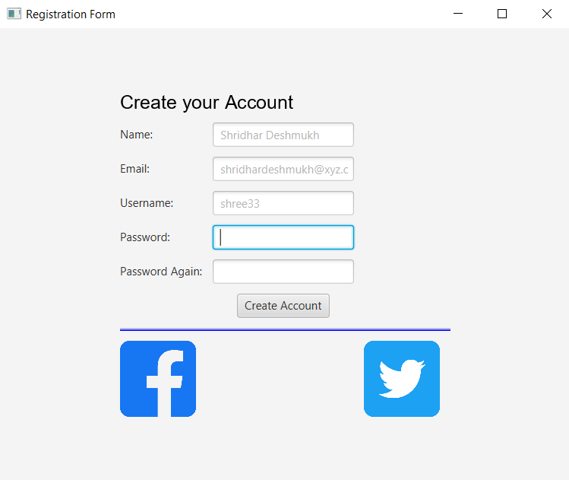

Reg.txt

